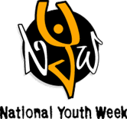 **IT’S YOUTH WEEK AND WE WANT YOU TO CELEBARATE**

**HOW AWESOME YOUTH ARE!!!**

**May 4th 4:00 to 8:00pm**

**Activities include swimming 4:30 to 5:30, basketball, art , weight room, climbing wall and food**

BELTLINE AQUATIC CENTRE LOCATED AT: 221 12TH AVENUE SW

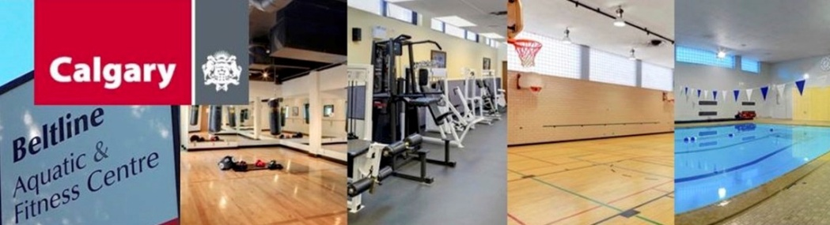

This is a FREE activity for youth 12 to 24

Brought to you by The City of Calgary, CommunityWise &

Youth Sector Agencies.